**Introduction:**

The "Movie Show Time" is a program designed to facilitate the process of booking movie tickets. This C program offers a user-friendly interface for customers to check available movies, select theatre and showtimes, choose seats, and complete the booking process. The primary objective of this package is to book tickets easily by providing convenience and efficiency to both customers and theatre staff.

Function of this package:

Users can select a list of available movies and view the title of the movie. The program displays a schedule of showtimes for the selected movie, allowing users to pick a suitable time slot. Customers can choose their preferred seats from a seating arrangement, with updates on seat availability. After selecting seats and showtime, users are prompted to confirm their booking and enter their contact information. The program generates and displays booking details, which include a unique booking ID and the price of the ticket.

Code Overview:

Header Inclusions:

The code includes necessary header files like ‘stdio.h’,’string.h’, and ‘time.h’.

Variable Declarations:

Various arrays and variables are declared to store movie information, user input, and program choices.

Main menu:

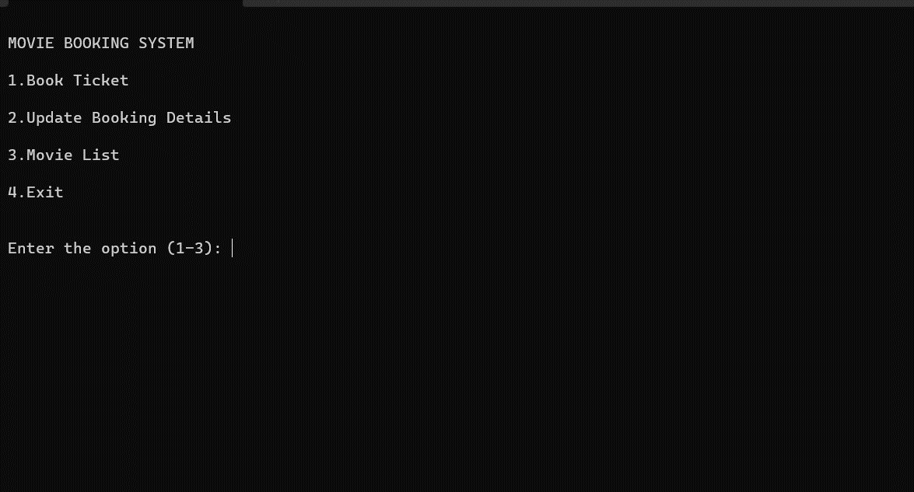

Book ticket:

Select a Movie

Select Show timing.

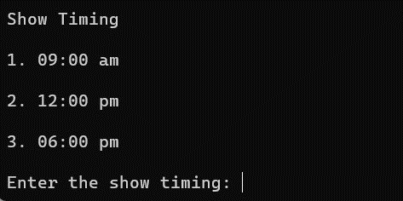

Give the layout of the theatre

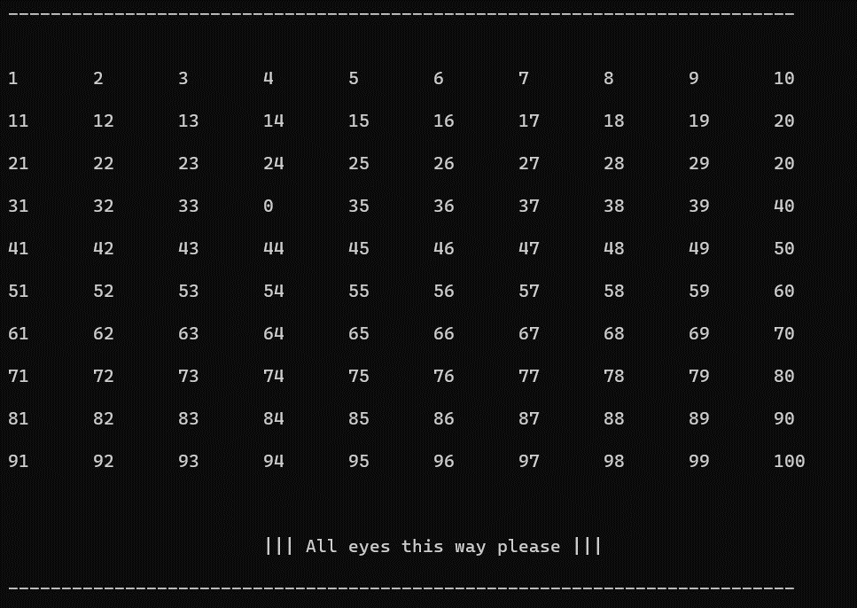

User input:

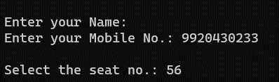

Invoice of the ticket:

Again go backs to the main menu

Update Booking Details:

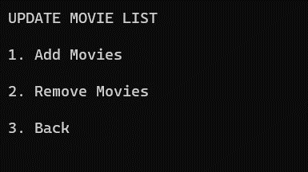

Movies List:

Show the movie list available

